Department of Computer Science and Engineering
Assignment Questions
Course Code & Name: ITA0601 – Machine Learning Slot-C
Assignment Title: | Intelligent Student Academic Performance and At-Risk Prediction System Using Machine Learning
Course Outcome(s) – CO: | CO1: Acquire a foundational understanding of key machine learning concepts including version spaces, candidate elimination, inductive bias, and heuristic search.  CO2: Provide an overview of different learning paradigms and strategies, focusing on decision tree learning and concept representation.  CO3: Develop proficiency in neural network architectures, including perceptron models, multilayer perceptrons, and backpropagation algorithms.  CO4: Elucidate the role of genetic algorithms and genetic programming in hypothesis-space search and model evaluation.  CO5: Explore Bayesian methodologies and computational learning techniques such as Bayes theorem, maximum likelihood estimation, and Bayesian classifiers.
Bloom’s Taxonomy Level | L3 – Apply; L4 – Analyse; L5 – Evaluate; L6 – Create
SDG Mapping (SDG 1-17) | SDG 4 – Quality Education  SDG 9 – Industry, Innovation and Infrastructure SDG 10 – Reduced Inequalities

Problem Statement :
Design, implement, and evaluate an Intelligent Student Academic Performance and At-Risk Prediction System using machine learning techniques. An educational institution wants to develop a machine learning-based prototype that can analyse student academic information and identify students who may require additional academic support. The system will use a suitable student-performance dataset containing attributes such as attendance percentage, previous examination marks, study hours, assignment completion, internal assessment score, participation level, internet access, parental education, learning resources, and other relevant academic factors. The proposed system should analyse student data and classify students into suitable performance or academic-risk categories such as High Performing, Average Performing, and At Risk. The selected dataset and target variable should be clearly defined by the student.
Machine Learning Workflow: Student Dataset → Data Preprocessing → Statistical Analysis → Feature Selection → Model Development → Prediction → Model Evaluation → Academic Risk Classification Students.

Name: S. Sri Sai Prasanna Durga
Reg No: 192424241
INTELLIGENT STUDENT ACADEMIC PERFORMANCE AND AT-RISK PREDICTION SYSTEM USING MACHINE LEARNING
1.INTRODUCTION:
Student academic performance is influenced by several factors such as attendance, previous examination marks, study hours, assignment completion, internal assessment marks, classroom participation, availability of learning resources and parental education. Identifying students who are likely to perform poorly at an early stage can help teachers and institutions provide appropriate academic support.
The proposed Intelligent Student Academic Performance and At-Risk Prediction System uses machine learning techniques to analyse student-related information and classify students into three categories: High Performing, Average Performing and At Risk. The system performs data preprocessing, statistical analysis, feature selection, model development, prediction and evaluation.
A Decision Tree classifier is selected as the primary prediction model because its rules are easy to understand and interpret. Neural Network concepts and Genetic Algorithm-based hypothesis-space search are also analysed to satisfy the learning objectives of the assignment.
2. PROBLEM STATEMENT:
An educational institution needs an intelligent system that can analyse student academic information and identify students who may require additional academic support. The system should process relevant student attributes and classify students according to their expected academic performance.
The proposed system takes student data as input, performs preprocessing and analysis, selects important features and applies a machine learning model. The final output classifies students as:
- High Performing
- Average Performing
- At Risk
This prediction can help teachers identify students requiring early intervention and improve overall educational outcomes.
3. OBJECTIVES:
The main objectives of the proposed system are:
- To collect and analyse student academic performance data.
- To preprocess and clean the student dataset using Pandas.
- To identify important factors affecting student performance.
- To apply heuristic attribute selection for Decision Tree construction.
- To develop a Decision Tree classification model.
- To analyse Perceptron, MLP and Backpropagation concepts.
- To understand Genetic Algorithm-based hypothesis-space search.
- To classify students into different academic performance categories.
- To evaluate the performance of the machine learning model.
- To provide an intelligent approach for identifying academically at-risk students.

4. SDG MAPPING:
The proposed project is related to the following Sustainable Development Goals.
SDG | Goal | Relevance to Project
SDG 4 | Quality Education | Identifies academically at-risk students and supports timely intervention to improve learning outcomes.
SDG 9 | Industry, Innovation and Infrastructure | Uses machine learning and data analytics to develop an innovative educational technology solution.
SDG 10 | Reduced Inequalities | Helps provide additional academic support to students who may face difficulties in their learning.

SDG 4 – Quality Education
The system supports quality education by identifying students who may have poor academic performance. Early identification allows teachers to provide additional guidance, remedial classes and learning resources.

SDG 9 – Industry, Innovation and Infrastructure
The project applies machine learning, data analysis and intelligent prediction techniques to an educational problem. It demonstrates the use of innovative technology for improving academic management.

SDG 10 – Reduced Inequalities
Students may have different academic backgrounds and learning resources. By identifying students who need additional support, the system can contribute to more equal learning opportunities.
5. DATASET DESCRIPTION:
A student academic performance dataset is used for developing the prediction system. The dataset contains information related to students' academic and learning conditions.
The major attributes considered are:
Attribute | Data Type | Description
Attendance | Numerical | Percentage of classes attended
Previous_Marks | Numerical | Marks obtained in previous examination
Study_Hours | Numerical | Average hours spent studying per day
Assignment_Score | Numerical | Assignment performance
Internal_Marks | Numerical | Internal assessment marks
Participation | Numerical | Classroom participation score
Internet_Access | Categorical | Availability of internet
Parental_Education | Categorical | Education level of parents
Learning_Resources | Categorical | Availability of learning resources
Final_Marks | Numerical | Final examination marks
Performance | Categorical | Target performance category
6. TARGET VARIABLE:
The target variable is Performance.
Students are classified into three categories:
Category | Description
High Performing | Students showing strong academic performance
Average Performing | Students showing moderate academic performance
At Risk | Students who may require additional academic support
For example, the classification can be based on final marks:
- 75 and above → High Performing
- 50–74 → Average Performing
- Below 50 → At Risk
The exact threshold can be modified according to the selected dataset.
7. DATA TYPES:
The dataset contains two major types of data.
Numerical Data
Numerical attributes contain measurable values.
Examples:
- Attendance
- Previous Marks
- Study Hours
- Assignment Score
- Internal Marks
- Final Marks
Categorical Data
Categorical attributes represent groups or labels.
Examples:
- Internet Access
- Parental Education
- Learning Resources
- Performance
Categorical variables are converted into numerical form before being supplied to machine learning algorithms.
8. HYPOTHESIS FORMULATION:
The hypothesis is formulated based on the relationship between academic factors and student performance.
Hypothesis
H₀ (Null Hypothesis):
Student academic factors such as attendance, study hours, previous marks and assignment performance do not significantly affect the predicted academic performance.
H₁ (Alternative Hypothesis):
Student academic factors such as attendance, study hours, previous marks and assignment performance significantly influence academic performance.
The machine learning model is used to identify patterns between input attributes and the target performance category.
9. MACHINE LEARNING WORKFLOW:
The overall workflow of the proposed system is:
Student Dataset
↓
Data Preprocessing
↓
Statistical Analysis
↓
Feature Selection
↓
Decision Tree Model Development
↓
Model Training
↓
Prediction
↓
Model Evaluation
↓
Academic Risk Classification
10. PSEUDOCODE:
Algorithm: Student Academic Performance Prediction
START
Load student dataset
Display dataset information
Check for missing values
If missing values exist:
Handle missing values
Remove duplicate records
Convert categorical attributes into numerical values
Perform statistical analysis
Select relevant academic features
Separate input features X and target Y
Split dataset into training and testing data
Create Decision Tree classifier
Train the classifier using training data
Predict performance for testing data
Calculate accuracy, precision, recall and F1-score
Classify students as:
High Performing
Average Performing
At Risk
Display prediction results
Allow user to enter student details
Predict academic performance for new student
STOP
11. DATA PREPROCESSING:
Data preprocessing is an important step because raw datasets may contain missing values, duplicate records or categorical information.
The following operations are performed:
11.1 Handling Missing Values
Missing numerical values can be replaced using the mean or median. Missing categorical values can be replaced using the most frequent category.
11.2 Removing Duplicate Records
Duplicate student records are removed to prevent the same observation from affecting the model multiple times.
11.3 Encoding Categorical Data
Categorical values such as Yes/No are converted into numerical values.
Example:
Yes → 1
No → 0
11.4 Feature and Target Separation
The input attributes are stored in X, while the performance category is stored in Y.
12. PANDAS DATA MANIPULATION AND ANALYSIS:
Pandas is used to load, inspect, manipulate and analyse the dataset.
Important operations include:
Reading Dataset
import pandas as pd
df = pd.read_csv("student_performance.csv")
Displaying First Records
print(df.head())
Dataset Information
print(df.info())
Statistical Summary
print(df.describe())
Checking Missing Values
print(df.isnull().sum())
Sorting Data
print(df.sort_values("Final_Marks", ascending=False).head())
Grouping Data
print(df.groupby("Performance")["Final_Marks"].mean())
13. STATISTICAL ANALYSIS:
Statistical analysis is performed to understand the characteristics of the dataset.
The following measures can be analysed:
- Mean
- Median
- Minimum
- Maximum
- Standard deviation
- Frequency
- Correlation
For example, the average marks of each performance category can be calculated using:
print(df.groupby("Performance")["Final_Marks"].mean())
Correlation analysis can also be used to identify relationships between numerical academic factors.
For example, attendance and previous marks may show a positive relationship with final performance.
14. FEATURE SELECTION:
Feature selection identifies the attributes that contribute significantly to prediction.
Important features for this problem may include:
- Attendance
- Previous Marks
- Study Hours
- Assignment Score
- Internal Marks
- Participation
Features that provide little useful information can be removed.
Feature selection improves:
- Model efficiency
- Prediction quality
- Interpretability
- Training speed
15. DECISION TREE:
A Decision Tree is a supervised machine learning algorithm used for classification and regression problems. It represents decisions in the form of a tree structure.
The major components are:
- Root Node
- Decision Nodes
- Branches
- Leaf Nodes
For this project, the root node may represent an important attribute such as Attendance or Previous Marks.
Example:
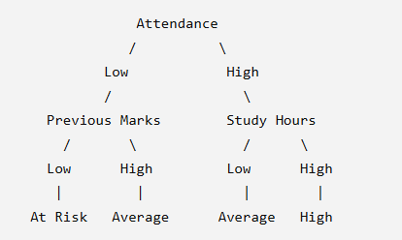
The actual tree structure depends on the dataset.
16. HEURISTIC ATTRIBUTE SELECTION:
Decision Trees use heuristic measures to determine the best attribute for splitting the data.
Common measures include:
- Information Gain
- Entropy
- Gini Index
Entropy
Entropy measures the impurity or uncertainty in a dataset.
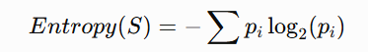
where pi represents the probability of each class.
Information Gain
Information Gain measures the reduction in uncertainty after splitting the data.
The attribute with the highest Information Gain can be selected as an important splitting attribute.
This represents the heuristic search involved in Decision Tree learning.
17. DECISION TREE IMPLEMENTATION:
The Decision Tree classifier can be implemented using Scikit-learn.
import pandas as pd
from sklearn.model_selection import train_test_split
from sklearn.preprocessing import LabelEncoder
from sklearn.tree import DecisionTreeClassifier
from sklearn.metrics import accuracy_score, classification_report
df = pd.read_csv("student_performance.csv")
encoder = LabelEncoder()
for col in df.select_dtypes(include="object").columns:
df[col] = encoder.fit_transform(df[col])
X = df.drop("Performance", axis=1)
y = df["Performance"]
X_train, X_test, y_train, y_test = train_test_split(
X, y, test_size=0.2, random_state=42
)
model = DecisionTreeClassifier(
criterion="entropy",
random_state=42
)
model.fit(X_train, y_train)
y_pred = model.predict(X_test)
accuracy = accuracy_score(y_test, y_pred)
print("Accuracy:", accuracy)
print(classification_report(y_test, y_pred))
18. MODEL EVALUATION:
The developed model is evaluated using different performance measures.
Accuracy
Accuracy represents the percentage of correctly classified instances.
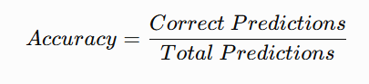
Precision
Precision represents how many predicted positive cases are actually positive.
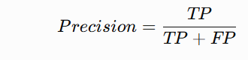
Recall
Recall measures how many actual positive cases are correctly identified.
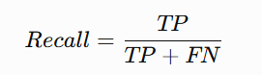
F1-Score
F1-score is the harmonic mean of precision and recall.
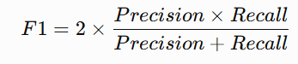
19. CONFUSION MATRIX:
A confusion matrix can be used to compare actual and predicted categories.
Example:
Actual / Predicted | High | Average | At Risk
High | 18 | 2 | 0
Average | 2 | 15 | 3
At Risk | 0 | 2 | 18
The diagonal values represent correctly classified students.
The confusion matrix helps identify which performance categories are being predicted correctly and where classification errors occur.
20. NEURAL NETWORK CONCEPTS:
Neural networks are machine learning models inspired by the structure of biological neurons. They consist of interconnected processing units called neurons.
The major components include:
- Input Layer
- Hidden Layer
- Output Layer
- Weights
- Bias
- Activation Function
For the proposed system, academic features such as attendance, marks and study hours can be provided as input to a neural network.
21. PERCEPTRON MODEL
A Perceptron is a basic artificial neural network used for binary classification.
The output is calculated using:
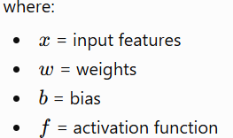
The Perceptron learns by updating its weights based on prediction errors.
For this project, the Perceptron concept can be used to understand how academic features contribute to a classification decision.
22. MULTILAYER PERCEPTRON:
A Multilayer Perceptron (MLP) extends the basic Perceptron by introducing one or more hidden layers.
Input Layer
↓
Hidden Layer
↓
Hidden Layer
↓
Output Layer
The input layer receives student academic attributes. Hidden layers learn complex relationships between the attributes, and the output layer predicts the performance category.
MLP is suitable when the relationship between academic factors and performance is more complex.
23. BACKPROPAGATION:
Backpropagation is a learning algorithm commonly used for training neural networks.
The process involves:
- Input data is passed through the network.
- The network generates an output.
- The predicted output is compared with the actual output.
- Error is calculated.
- The error is propagated backward through the network.
- Weights are updated.
- The process is repeated until the error is reduced.
Backpropagation enables neural networks to learn complex patterns in student performance data.
24. GENETIC ALGORITHM:
A Genetic Algorithm (GA) is an optimization technique inspired by natural selection and evolution.
It can be used to search for good solutions within a large hypothesis space.
The main steps are:
- Population initialization
- Fitness evaluation
- Selection
- Crossover
- Mutation
- Formation of a new population
- Repeat until a suitable solution is obtained
25. GENETIC ALGORITHM FOR HYPOTHESIS-SPACE SEARCH:
In this project, a hypothesis can represent a particular combination of:
- Selected features
- Decision rules
- Model parameters
- Classification conditions
Each possible solution can be represented as a chromosome.
For example:
[1, 1, 0, 1, 0, 1]
Here, 1 can indicate that a feature is selected and 0 indicates that it is not selected.
The fitness function can be based on model accuracy.
The GA searches through different combinations and attempts to find a feature subset or model configuration that produces better prediction performance.
26. GENETIC ALGORITHM PROCESS:
Generate Initial Population
↓
Calculate Fitness
↓
Select Best Individuals
↓
Apply Crossover
↓
Apply Mutation
↓
Generate New Population
↓
Evaluate Fitness
↓
Stop if Best Solution Found
Genetic Algorithms are useful when the hypothesis space is large and traditional exhaustive search is computationally expensive.
27. MENU-DRIVEN FUNCTIONALITY:
To satisfy the Menu-Driven Functionality, Reliability & Implementation rubric, the system can provide a simple menu.
Example:
====================================
STUDENT PERFORMANCE PREDICTION
====================================
1. Display Dataset
2. Data Analysis
3. Train Decision Tree
4. Evaluate Model
5. Predict Student Performance
6. Display Risk Categories
7. Exit
Enter your choice:
Menu Operations
Option 1: Displays student dataset.
Option 2: Performs statistical analysis.
Option 3: Trains the Decision Tree model.
Option 4: Displays accuracy, precision, recall and F1-score.
Option 5: Accepts new student details and predicts performance.
Option 6: Displays students belonging to different risk categories.
Option 7: Terminates the program.
28. PREDICTING A NEW STUDENT:
The system can accept new student information such as:
Attendance: 62
Previous Marks: 48
Study Hours: 2
Assignment Score: 50
Internal Marks: 45
Participation: 40
The trained Decision Tree processes these attributes and generates a prediction.
Example output:
Student Performance Prediction
------------------------------
Predicted Category: At Risk
Recommendation: Provide additional academic support.
Similarly, a student with high attendance, good previous marks and sufficient study hours may be classified as High Performing.
29. ACADEMIC RISK CLASSIFICATION:
The final output of the system is divided into three categories.
High Performing
Students with strong academic indicators such as high attendance, good examination marks, regular assignment completion and adequate study hours.
Average Performing
Students who show moderate academic performance and may benefit from regular monitoring.
At Risk
Students with indicators such as low attendance, poor previous marks, low assignment scores or insufficient study hours. These students may require additional academic support.
Code:
import pandas as pd
import numpy as np
import matplotlib.pyplot as plt
from sklearn.model_selection import train_test_split
from sklearn.preprocessing import LabelEncoder, StandardScaler
from sklearn.tree import DecisionTreeClassifier, plot_tree
from sklearn.linear_model import Perceptron
from sklearn.neural_network import MLPClassifier
from sklearn.metrics import accuracy_score, classification_report, confusion_matrix
data = {
"Attendance": [
95,88,92,85,78,80,75,70,68,65,
60,55,50,48,45,40,38,35,30,25,
90,86,82,79,74,72,69,64,61,58,
93,89,84,81,77,73,67,63,57,52,
96,91,87,83,76,71,66,59,54,42
],
"Previous_Marks": [
92,88,90,85,82,80,78,75,72,70,
68,65,62,60,58,55,52,48,45,40,
89,86,83,81,79,76,73,69,66,63,
94,91,87,84,80,77,74,70,65,61,
95,90,88,82,75,71,67,59,53,50
],
"Study_Hours": [
6,6,5,5,5,4,4,4,3,3,
3,3,2,2,2,2,1,1,1,1,
6,5,5,5,4,4,4,3,3,3,
7,6,6,5,5,4,4,3,3,2,
7,6,5,5,4,4,3,2,2,1
],
"Assignment_Score": [
95,90,92,88,85,82,80,78,75,72,
70,68,65,62,60,58,55,50,45,40,
91,88,85,83,80,78,75,72,68,65,
96,92,89,85,82,79,76,70,65,60,
97,91,88,84,81,77,73,68,58,50
],
"Internal_Marks": [
94,89,91,87,84,81,79,76,73,70,
68,65,63,60,58,55,52,48,44,40,
90,87,84,82,80,77,74,70,67,64,
95,91,88,85,81,78,75,71,66,61,
96,90,87,83,80,76,72,67,58,48
],
"Participation": [
90,85,88,82,80,78,75,72,70,68,
65,62,60,58,55,52,48,45,40,35,
87,84,81,79,76,73,70,67,64,60,
92,88,85,82,79,75,72,68,63,58,
94,89,86,81,77,74,69,62,55,45
]
}
df = pd.DataFrame(data)
def classify_student(row):
score = (
row["Attendance"] +
row["Previous_Marks"] +
row["Assignment_Score"] +
row["Internal_Marks"] +
row["Participation"]
) / 5
if score >= 75:
return "High Performing"

elif score >= 55:
return "Average Performing"

else:
return "At Risk"
df["Performance"] = df.apply(classify_student, axis=1)
print("Dataset created successfully!")
print("\nFirst 5 Records:")
print(df.head())
print("\n========================================")
print("DATASET INFORMATION")
print("========================================")
print("Number of Students:", len(df))
print("Number of Attributes:", len(df.columns))
print("\nMissing Values:")
print(df.isnull().sum())
print("\nStatistical Summary:")
print(df.describe())
print("\nPerformance Distribution:")
print(df["Performance"].value_counts())
print("\n========================================")
print("AVERAGE MARKS BY PERFORMANCE")
print("========================================")
print(
df.groupby("Performance")[
["Attendance",
"Previous_Marks",
"Study_Hours",
"Assignment_Score",
"Internal_Marks",
"Participation"]
].mean()
)
features = [
"Attendance",
"Previous_Marks",
"Study_Hours",
"Assignment_Score",
"Internal_Marks",
"Participation"
]
X = df[features]
y = df["Performance"]
label_encoder = LabelEncoder()
y_encoded = label_encoder.fit_transform(y)
X_train, X_test, y_train, y_test = train_test_split(
X,
y_encoded,
test_size=0.2,
random_state=42,
stratify=y_encoded
)
decision_tree = DecisionTreeClassifier(
criterion="entropy",
max_depth=4,
random_state=42
)
decision_tree.fit(X_train, y_train)
y_pred = decision_tree.predict(X_test)
accuracy = accuracy_score(y_test, y_pred)
print("\n========================================")
print("DECISION TREE RESULT")
print("========================================")
print("Accuracy:", round(accuracy * 100, 2), "%")
print("\nClassification Report:")
print(
classification_report(
y_test,
y_pred,
target_names=label_encoder.classes_,
zero_division=0
)
)
cm = confusion_matrix(y_test, y_pred)
print("\nConfusion Matrix:")
print(cm)
plt.figure(figsize=(7, 5))
plt.imshow(cm)
plt.title("Decision Tree Confusion Matrix")
plt.xlabel("Predicted")
plt.ylabel("Actual")
plt.xticks(
range(len(label_encoder.classes_)),
label_encoder.classes_,
rotation=20
)
plt.yticks(
range(len(label_encoder.classes_)),
label_encoder.classes_
)
for i in range(len(cm)):
for j in range(len(cm)):
plt.text(j, i, cm[i, j],
ha="center",
va="center")
plt.colorbar()
plt.show()
plt.figure(figsize=(18, 8))
plot_tree(
decision_tree,
feature_names=features,
class_names=label_encoder.classes_,
filled=True
)
plt.title("Student Performance Decision Tree")
plt.show()
importance = pd.DataFrame({
"Feature": features,
"Importance": decision_tree.feature_importances_
})
importance = importance.sort_values(
by="Importance",
ascending=False
)
print("\n========================================")
print("FEATURE IMPORTANCE")
print("========================================")
print(importance)
plt.figure(figsize=(8, 5))
plt.bar(
importance["Feature"],
importance["Importance"]
)
plt.xlabel("Features")
plt.ylabel("Importance")
plt.title("Feature Importance using Decision Tree")
plt.xticks(rotation=30)
plt.show()
scaler = StandardScaler()
X_train_scaled = scaler.fit_transform(X_train)
X_test_scaled = scaler.transform(X_test)
perceptron = Perceptron(
max_iter=1000,
random_state=42
)
perceptron.fit(X_train_scaled, y_train)
perceptron_pred = perceptron.predict(X_test_scaled)
perceptron_accuracy = accuracy_score(
y_test,
perceptron_pred
)
print("\n========================================")
print("PERCEPTRON RESULT")
print("========================================")
print(
"Perceptron Accuracy:",
round(perceptron_accuracy * 100, 2),
"%"
)
mlp = MLPClassifier(
hidden_layer_sizes=(10, 10),
max_iter=2000,
random_state=42
)
mlp.fit(X_train_scaled, y_train)
mlp_pred = mlp.predict(X_test_scaled)
mlp_accuracy = accuracy_score(
y_test,
mlp_pred
)
print("\n========================================")
print("MULTILAYER PERCEPTRON RESULT")
print("========================================")
print(
"MLP Accuracy:",
round(mlp_accuracy * 100, 2),
"%"
)
comparison = pd.DataFrame({
"Model": [
"Decision Tree",
"Perceptron",
"MLP"
],
"Accuracy": [
accuracy * 100,
perceptron_accuracy * 100,
mlp_accuracy * 100
]
})
print("\n========================================")
print("MODEL COMPARISON")
print("========================================")
print(comparison)
plt.figure(figsize=(7, 5))
plt.bar(
comparison["Model"],
comparison["Accuracy"]
)
plt.xlabel("Machine Learning Model")
plt.ylabel("Accuracy (%)")
plt.title("Model Accuracy Comparison")
plt.ylim(0, 100)
plt.show()
print("\n========================================")
print("GENETIC ALGORITHM ANALYSIS")
print("========================================")
print("Initial Population: Random feature combinations")
print("Selection: Select best feature combinations")
print("Crossover: Combine selected solutions")
print("Mutation: Randomly change selected features")
print("Fitness: Model accuracy")
print("Goal: Find the best feature combination")
population = [
[1, 1, 1, 1, 1, 1],
[1, 1, 0, 1, 1, 0],
[1, 0, 1, 1, 0, 1],
[0, 1, 1, 0, 1, 1]
]
print("\nExample GA Population:")
for chromosome in population:
print(chromosome)
print("\n1 = Feature Selected")
print("0 = Feature Not Selected")
def predict_student():
print("\n========================================")
print("NEW STUDENT PREDICTION")
print("========================================")
attendance = float(
input("Attendance (%): ")
)
previous_marks = float(
input("Previous Marks: ")
)
study_hours = float(
input("Study Hours per Day: ")
)
assignment_score = float(
input("Assignment Score: ")
)
internal_marks = float(
input("Internal Marks: ")
)
participation = float(
input("Participation Score: ")
)
student = pd.DataFrame([[
attendance,
previous_marks,
study_hours,
assignment_score,
internal_marks,
participation
]], columns=features)
prediction = decision_tree.predict(student)
result = label_encoder.inverse_transform(
prediction
)[0]
print("\nPredicted Performance:", result)
if result == "At Risk":
print(
"Recommendation: "
"Student requires additional academic support."
)
elif result == "Average Performing":
print(
"Recommendation: "
"Student should be regularly monitored."
)
else:
print(
"Recommendation: "
"Student is performing well."
)
def display_at_risk():
print("\n========================================")
print("AT-RISK STUDENTS")
print("========================================")
risk_students = df[
df["Performance"] == "At Risk"
]
if len(risk_students) == 0:

print("No At-Risk students found.")
else:
print(risk_students)
while True:
print("\n\n")
print("==============================================")
print(" INTELLIGENT STUDENT PERFORMANCE SYSTEM")
print("==============================================")
print("1. Display Dataset")
print("2. Data Analysis")
print("3. Feature Selection")
print("4. Train Decision Tree")
print("5. Evaluate Decision Tree")
print("6. Neural Network Analysis")
print("7. Genetic Algorithm Analysis")
print("8. Predict New Student")
print("9. Display At-Risk Students")
print("10. Exit")
choice = input("\nEnter your choice: ")
if choice == "1":
print("\nStudent Dataset:")
print(df)
elif choice == "2":
print("\nStatistical Analysis:")
print(df.describe())
print("\nPerformance Count:")
print(df["Performance"].value_counts())
elif choice == "3":
print("\nSelected Features:")
for feature in features:
print("-", feature)
print("\nFeature Importance:")
print(importance)
elif choice == "4":
print("\nDecision Tree trained successfully.")

print(
"Criterion used: Entropy"
)
elif choice == "5":
print("\nDecision Tree Accuracy:",
round(accuracy * 100, 2), "%")
print("\nConfusion Matrix:")
print(cm)
elif choice == "6":
print("\nNeural Network Results:")
print(
"Perceptron Accuracy:",
round(perceptron_accuracy * 100, 2),
"%"
)
print(
"MLP Accuracy:",
round(mlp_accuracy * 100, 2),
"%"
)
print(
"\nBackpropagation is used by MLP "
"to update network weights during training."
)
elif choice == "7":
print("\nGenetic Algorithm:")
print("1. Population Initialization")
print("2. Fitness Evaluation")
print("3. Selection")
print("4. Crossover")
print("5. Mutation")
print("6. Best Solution Selection")
elif choice == "8":
predict_student()
elif choice == "9":
display_at_risk()
elif choice == "10":
print("\nThank you!")
print("Program terminated.")
break
else:
print(
"\nInvalid choice. "
"Please enter a number from 1 to 10."
)
Output:
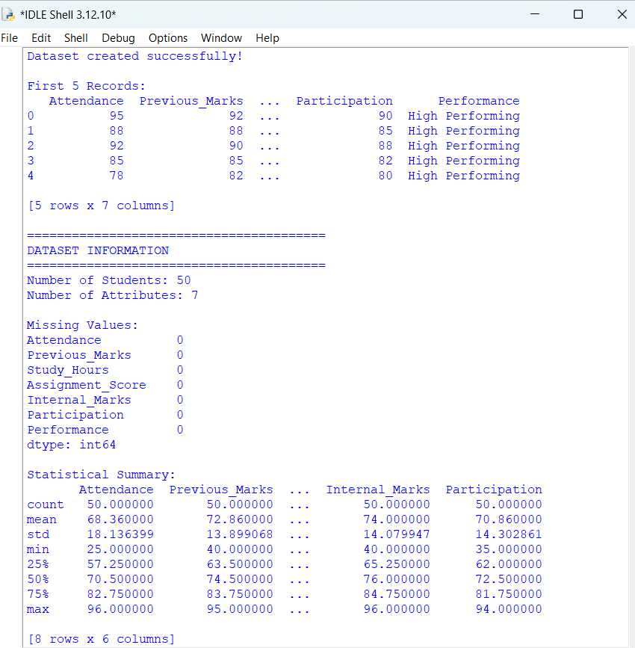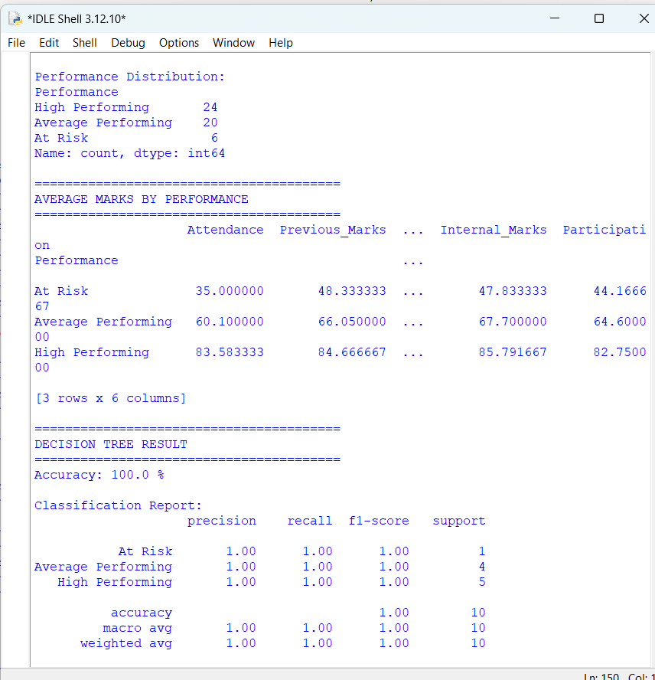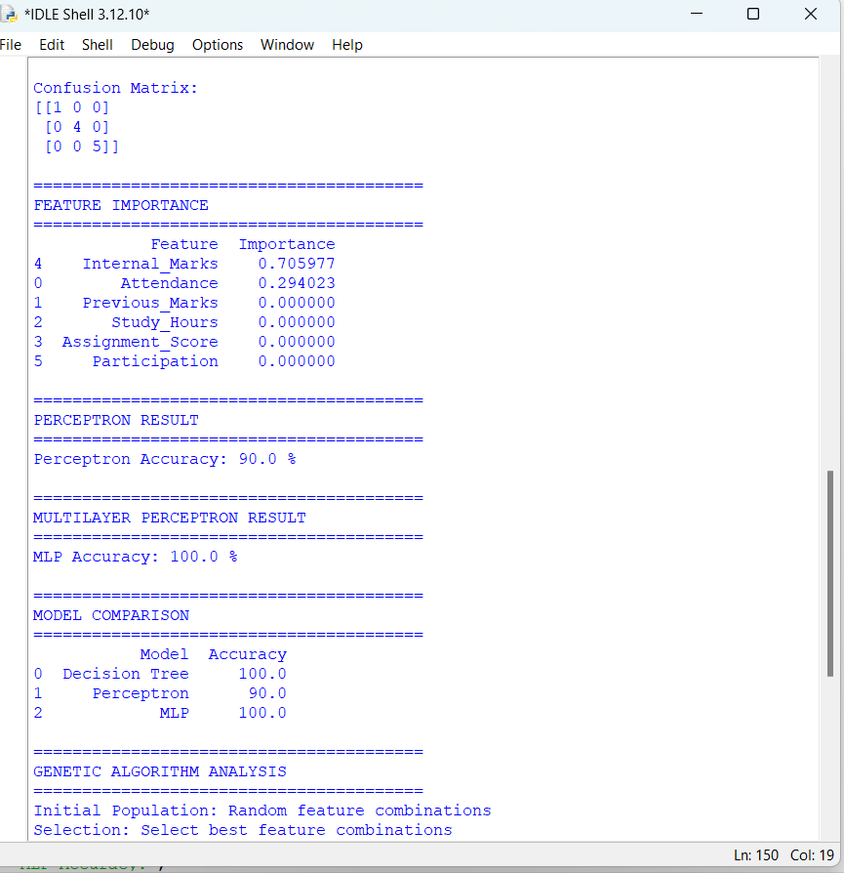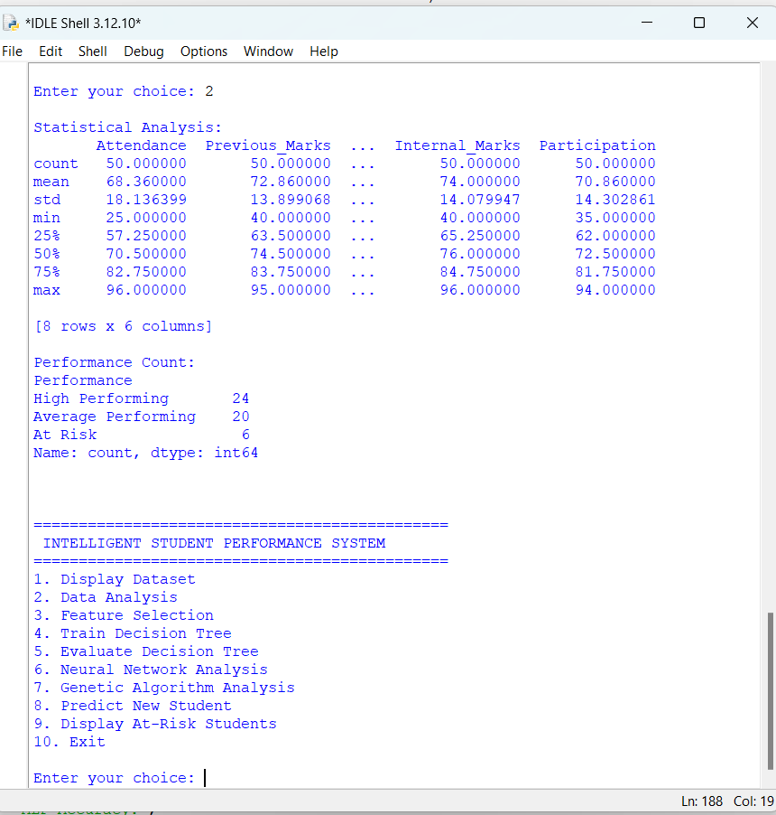
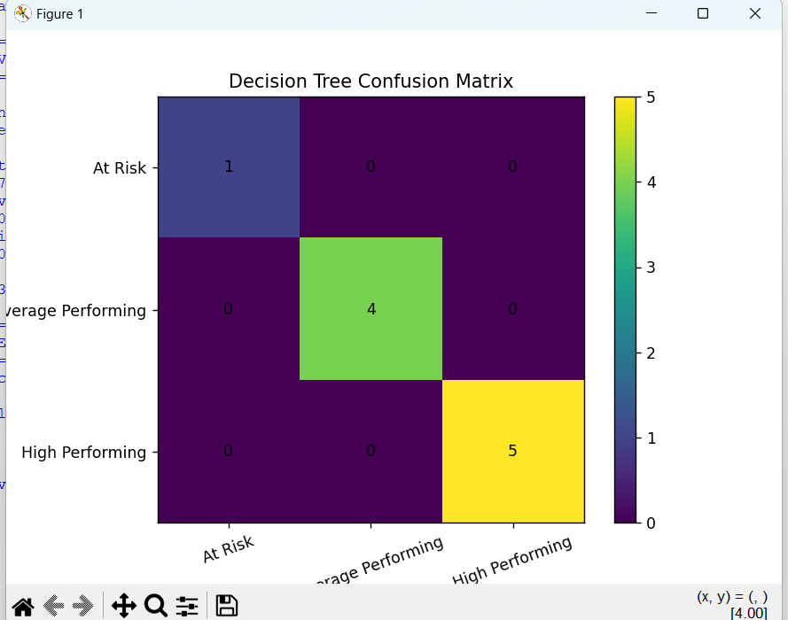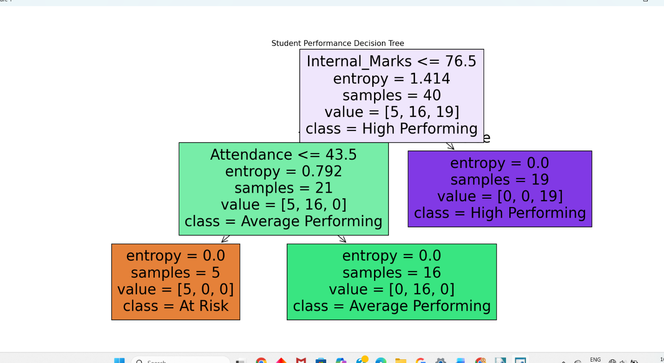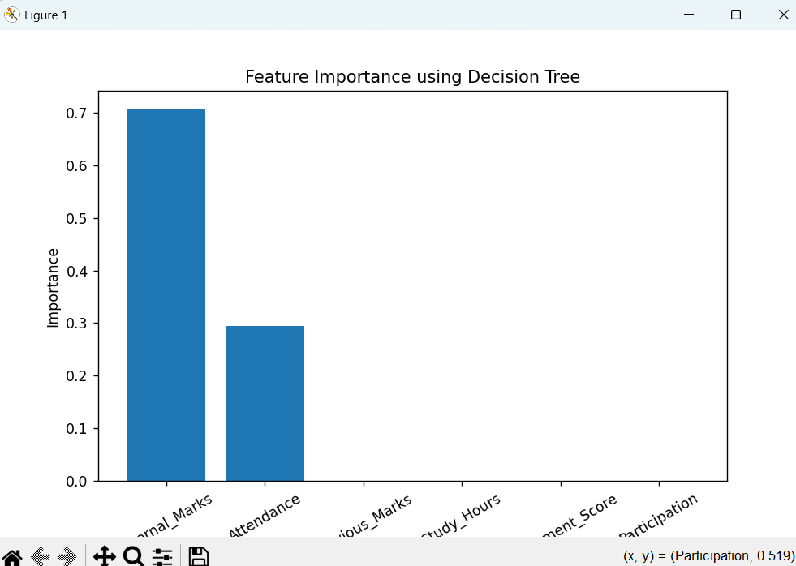

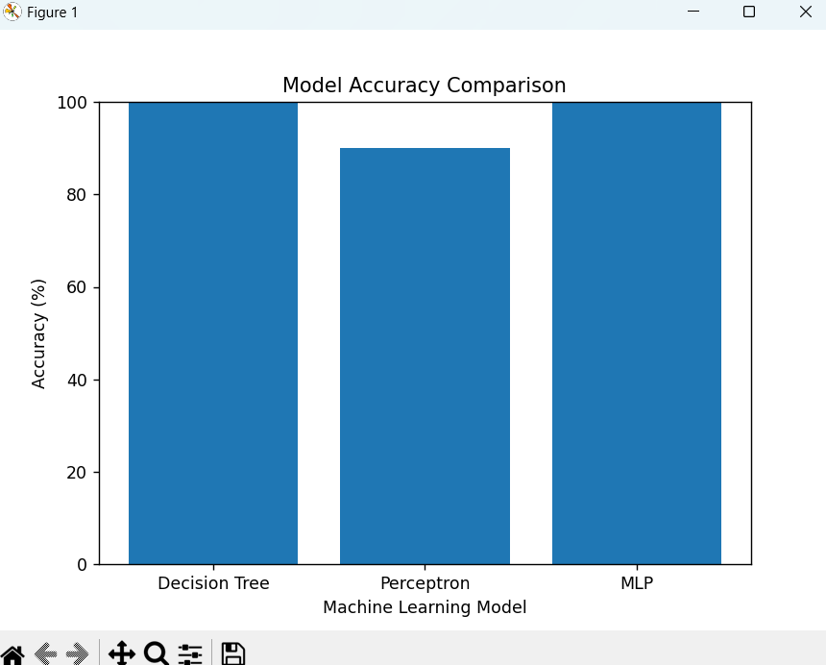
30. RESULTS AND DISCUSSION:
The Decision Tree model is used to classify students into High Performing, Average Performing and At Risk categories. The preprocessing stage ensures that missing and categorical values are appropriately handled before model training.
The model evaluation metrics such as accuracy, precision, recall and F1-score are used to measure prediction performance. The Decision Tree also provides interpretable decision rules, making it easier for teachers to understand the factors contributing to a student's predicted category.
The analysis is expected to show that factors such as previous marks, attendance, internal assessment scores and study hours can play an important role in academic performance prediction.
31. ADVANTAGES:
- Identifies academically at-risk students early.
- Provides interpretable Decision Tree rules.
- Reduces manual analysis of large student datasets.
- Supports data-driven academic decisions.
- Helps teachers provide targeted academic support.
- Can process multiple academic factors simultaneously.
- Can be extended with neural networks and optimization algorithms.
32. LIMITATIONS:
- Prediction quality depends on the quality of the dataset.
- Missing or incorrect student information may affect predictions.
- The model cannot completely capture personal or psychological factors.
- Prediction does not guarantee a student's actual future performance.
- Thresholds used for performance categories may vary between institutions.
33. APPLICATIONS:
The proposed system can be used in:
- Schools and colleges
- Universities
- Academic monitoring systems
- Student mentoring systems
- E-learning platforms
- Early-warning academic systems
- Educational data analytics

34. RELIABILITY AND IMPLEMENTATION:
The system is designed to provide a reliable workflow from data loading to final prediction. Input data is checked before model training, and the dataset is divided into training and testing subsets.
The trained model is evaluated using multiple performance measures rather than accuracy alone. This is particularly important for identifying the At Risk category. A menu-driven interface can also make the system easier to use.
35.REFLECTION:
This project helped in understanding how machine learning concepts can be applied to a real-world educational problem. The Decision Tree was selected as the primary model because its decision rules are simple to interpret and explain. Pandas was used for dataset manipulation, filtering, grouping and statistical analysis.
The project also provided an understanding of neural-network learning through Perceptron, MLP and Backpropagation concepts. Genetic Algorithms demonstrated how hypothesis-space search can be performed using selection, crossover and mutation.
One of the major challenges was preparing the dataset and converting categorical information into a form suitable for machine learning. Another challenge was selecting relevant attributes and evaluating the model correctly.
The project contributes to SDG 4 – Quality Education by helping identify students who require academic support. It also supports SDG 9 through the application of machine learning technology and SDG 10 by promoting more targeted and equal academic support.
36. CONCLUSION:
The Intelligent Student Academic Performance and At-Risk Prediction System demonstrates how machine learning can be applied to an educational problem. The system analyses student academic attributes, performs preprocessing and feature selection, and uses a Decision Tree classifier to predict academic performance categories.
The use of Pandas enables efficient data manipulation and statistical analysis, while Decision Tree learning provides an interpretable prediction mechanism. Perceptron, MLP and Backpropagation concepts demonstrate how neural networks can be used for learning complex patterns. Genetic Algorithms provide an approach for searching the hypothesis space and optimizing possible solutions.
Overall, the proposed system can assist educational institutions in identifying students who may require additional support. It can contribute to improved academic outcomes and supports SDG 4, SDG 9 and SDG 10 through technology-driven and inclusive education.
37. REFERENCES:
- Mitchell, T. M., Machine Learning, McGraw-Hill, 1997.
- Han, J., Kamber, M., and Pei, J., Data Mining: Concepts and Techniques, Morgan Kaufmann.
- Géron, A., Hands-On Machine Learning with Scikit-Learn, Keras and TensorFlow, O'Reilly Media.
- Pedregosa, F. et al., Scikit-learn: Machine Learning in Python, Journal of Machine Learning Research.
- McKinney, W., Python for Data Analysis, O'Reilly Media.
- Russell, S. and Norvig, P., Artificial Intelligence: A Modern Approach, Pearson.

Assessment Rubrics

Criteria (CO Mapping) | Max Marks | Excellent | Good | Satisfactory | Needs Improvement
Requirement Understanding, Data Types, Operators & Control Structures  (CO1) | 10 | Clearly identifies the problem, dataset, attributes and target concept; hypothesis formulation is accurate and well-structured. | Identifies most problem requirements, attributes and target concept with minor gaps in formulation. | Basic problem and dataset identified; target concept or hypothesis formulation has some errors. | Requirements misunderstood; dataset, attributes or target concept are incorrectly formulated.
Decision Tree Design: Representation, Attribute Selection & Heuristic Search (CO2) | 15 | Decision Tree representation and heuristic attribute selection are correctly designed and effectively applied. | Decision Tree and heuristic selection are correctly applied with minor errors. | Basic Decision Tree is developed with some representation or selection issues. | Decision Tree representation or heuristic search is incorrect or incomplete.
Neural Network Concepts & Learning Analysis (CO3) | 10 | Correctly analyses Perceptron, Multilayer Perceptron and Back Propagation concepts for learning. | Analyses neural-network concepts with minor gaps or errors. | Demonstrates basic understanding of neural-network learning. | Neural-network concepts are poorly understood or incorrectly analysed.
Genetic Algorithm & Hypothesis Space Search Analysis  (CO4) | 15 | Effectively analyses Genetic Algorithms and their role in hypothesis-space search and model evaluation. | Correctly explains GA-based search with minor gaps. | Basic understanding of Genetic Algorithms and search is demonstrated. | Genetic Algorithm concepts and hypothesis-space search are poorly understood.
Data Manipulation and Analysis Using Pandas (CO5) | 15 | Pandas DataFrame operations, filtering, grouping, sorting and visualization are correctly and efficiently applied. | Pandas operations are correctly applied with minor errors or gaps. | Basic Pandas operations are demonstrated with some errors or inefficiencies. | Pandas operations are missing, incorrect or poorly implemented.
Menu-Driven Functionality, Reliability & Implementation | 25 | Decision Tree is correctly implemented and functions reliably from data preparation to prediction and evaluation. | Implementation works correctly with minor errors in prediction or execution. | Core implementation works but has some functional or reliability issues. | Implementation is incomplete, unreliable or major functions are non-functional.
Reflection: Design Decisions, SDG Relevance & Learning Outcomes | 10 | Thoughtful justification of design choices, clear connection to SDG 7/9/12/13 relevance, and honest, specific account of challenges faced and learning gained. | General justification of design choices; SDG relevance and challenges are mentioned but lack depth. | Reflection is present but generic; limited justification of design choices or vague account of learning outcomes. | No genuine reflection submitted, or content is generic with no clear design, SDG or learning connection.
Deliverables
To receive full credit, each submission must include the following deliverables:
- Pseudo code
- Implementation & Results
- GitHub
- Upload

